THE PERCOLATION THEORY AND DC CONDUCTIVITY OF CARBON BLACK DISPERSED IN POLYETHYLENE

Josef Hampl, Ivana Pilarčíková

Czech Technical University ,K312, Faculty of Electrotechnical Engineering, Technická 2, 16627 Praha 6, Czech Republic, e-mail hampl@feld.cvut.cz

1. INTRODUCTION TO THE PERCOLATION OF CB COMPOSITE.
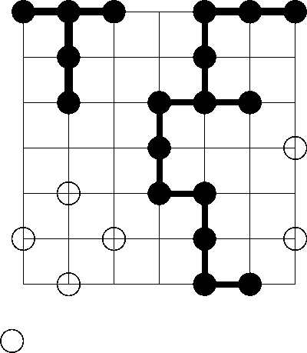
Percolation is a random process; it describes positions occupation in a percolation lattice. The occupation of the lattice points is random, that is each point is occupied or empty independent of the occupation status of its neighbours. Probability of a point occupation is p, probability of an empty point occupation is (1-p). A cluster is a group of neighbour occupied lattice points. Percolation theory deals with the number and properties of these clusters. Most interesting and most important are phenomena near the critical concentration c_{c} where for the first time a percolating cluster is formed. That percolation threshold c_{c} is concentration at which a cluster extends from one side of the system to other. The first Fig. illustrates these definitions on a simple square lattice.
CLUSTER
INFINITE CLUSTER
ISOLATED ATOM
The different percolation lattices have different percolation thresholds; it is 0.246 for BCC lattice or 0.198 for FCC lattice etc. Percolation can be solved exactly and different percolation lattices will contain clusters of different sizes and shapes their average properties follows from the statistic analysis. The solutions results yield the strength P of the infinite cluster and the mean cluster size S. P is probability of an arbitrary site belonging to the infinite network. Percolation theory was successfully applied to the solution of forest fires, oil fields, diffusion in disordered media etc.
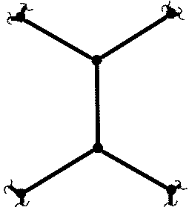
The Bethe lattice approximation is a method that could be used for CB-network formation in a homogeneous insulating material. The certain point of the Bethe lattice has z bonds (see the second Fig.). Each bond ends in neighbour site from which again z bonds emanate. For that Bethe lattice can be derived percolation threshold c_{c} :
Z = 3
$p_{ć}=c_{c}=\frac{1}{z−1}$ (1)
If a CB+PE mixture is prepared it is first fluid (no elasticity, low conductivity, finite clusters) but after some time it is a jelly with a finite elasticity, higher conductivity and also with infinite clusters. The crucial point for CB-network structure is value of the bond number z. Structural unit of the CB composite have very complex form known as grapelike or turbostratic therefore it is very difficult determine bond number z before experiment. Equation (1) explains results of many experimental works where percolation threshold was in the wide range between 0.06 – 20 volume percent of CB particles. The percolation theories give strictly geometrical solutions of these problems. Thermodynamic and kinetic solutions of a CB composite origin could be independent on percolation theory. Among CB-particles dispersed in polyethylene two different forces exist. First one is attractive Van der Waals force the second force is Coulomb repulsive force, which depends on the electrostatic charge level of particle. According to their ratio we obtain value of the percolation threshold.

2. DC CONDUCTIVITY OF CB COMPOSITE AND PERCOLATION EFFECTS
Conductive properties open a new branch of the network geometry. There exist important differences between conductivity σ of a homogeneous conductor (metal or semiconductor) and of a conductive composite (conductive powder + insulator). A normal conductor obeys Ohm´s law : J = σE here J is current density, Am⁻² , E is electric field intensity, Vm⁻¹ and conductivity is a constant in whole volume. J and E are vector quantities of the same directions.
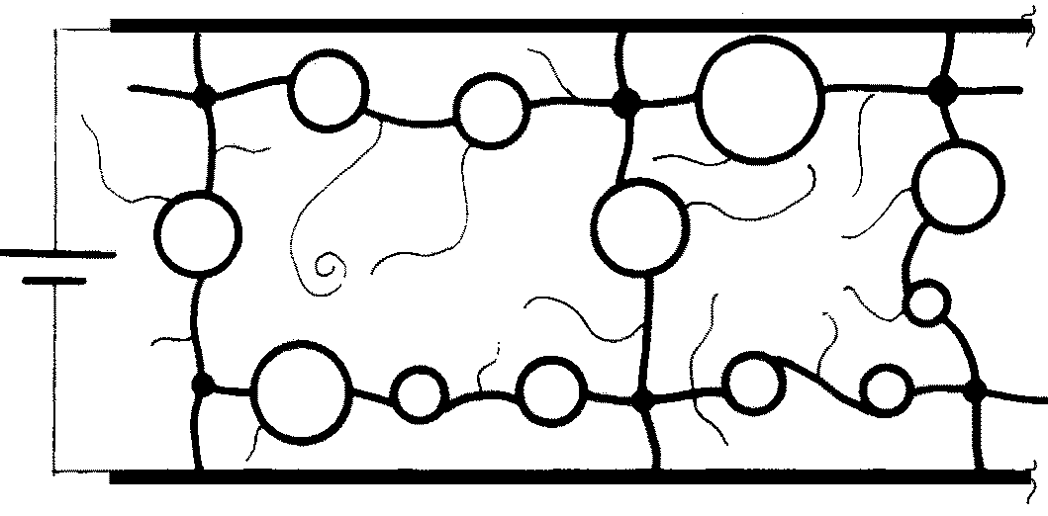
Conductivity of a conductive composite is conductivity of heterogeneous and anisotropic material. The conductive structure contains infinitive conductive clusters which are able carry electric current. CB particles create these clusters in described system. Experimental results indicate clearly that many clusters carry no current because they lead nowhere. It was derived that most of the mass of the CB particle network at the threshold concentration belongs to that dead ends of clusters without current and not to the backbone system which connect current between input and output electrodes. Situation describes this third Fig. It follows that backbone segments are often separated by loops that are roughly on the same potential so they have negligible influence on the total current. The complex structure of CB particles is accompanied by the appearance of closed and non-closed holes so the calculation of the volume concentration is another reason for the discrepancy between the theoretically and experimentally (from conductivity) found percolation concentrations. The electric field intensity E is not constant because of the strong structural anisotropy therefore it is necessary to use Volt direct method for resistance or conductance measuring and conductivity must be calculated from applied potential difference, total current and sample dimensions. It is impossible to use four-point or similar measuring methods.
DEAD ENDS
LOOP

3.CONCLUSIONS
- Percolation theory describes the CB network formation but we are unable to use these results for precise properties prognosis. The main reason is the character of the coagulating CB particles.
- The percolation threshold of conductive composites derived from the conductivity measuring differs from that one calculated or derived from other experimentally received values. It is connected with the structure of CB composite back bone structure.

[1] D.Staufer and A.Aharony, Introduction to Percolation Theory, Taylor and Francis, Bristol1994
[2] S.Nakamura,et al, Jpn. J.Appl. Phys. Vol. 36(1997) pp. 5163-5168
[3] I.Balberg, et all, International Journal of Madern Ph.B, Vol.18(2004) pp2091-121

